Github Info

1. American modern git hub repository

<https://github.com/rajnishroff2018/AmericanM.git>

1. Create account on <https://github.com/> and share it with Rajni.
2. Install git hub desktop from <https://desktop.github.com/>
3. Steps to push the files.
   1. Clone the repository

(<https://github.com/rajnishroff2018/AmericanM.git> )on your machine.

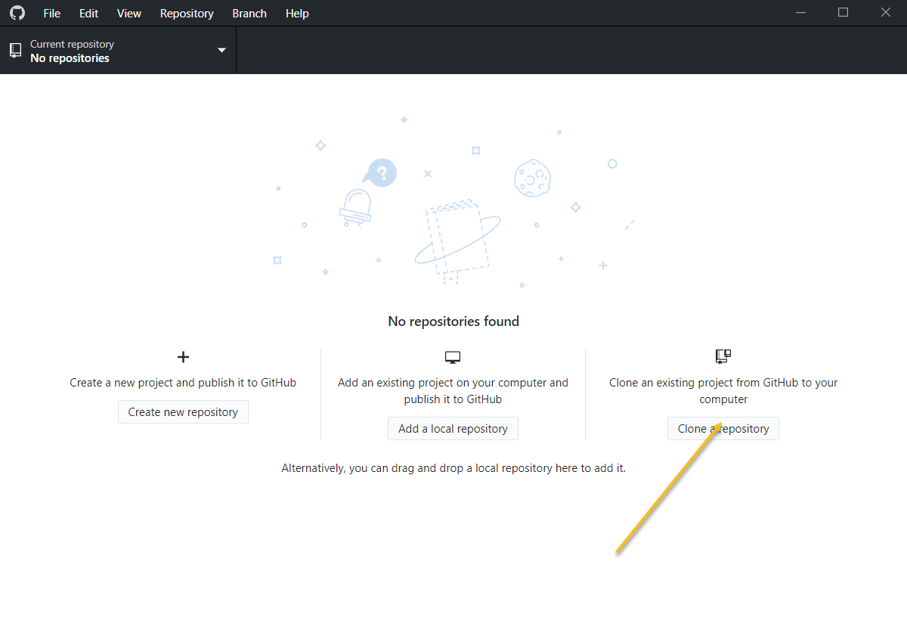

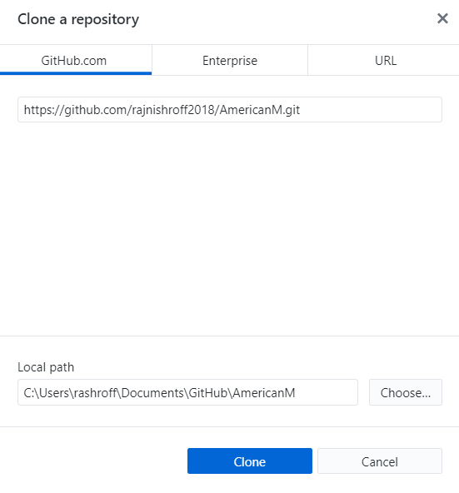

* 1. It will look something like this

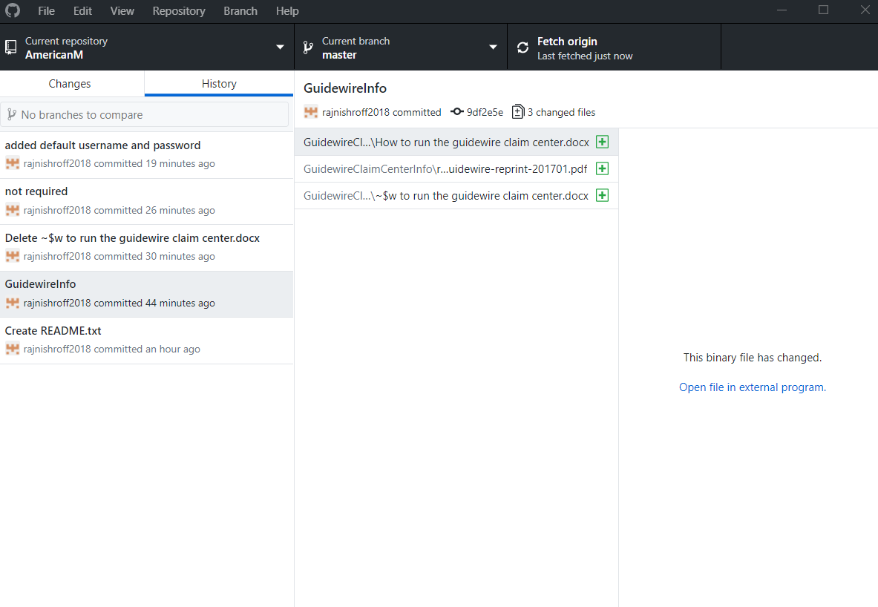

* 1. Click on “open this repository in explorer“ after choosing the “Changes” tab in upper left corner.
  2. This is the folder where you must copy all your files. Basically, this is the project code directory.
  3. Copy a new file or edit any existing file in this directory and then go to github desktop application and click on “changes” tab. For example I changed “How to run the guidewire claim center.docx”

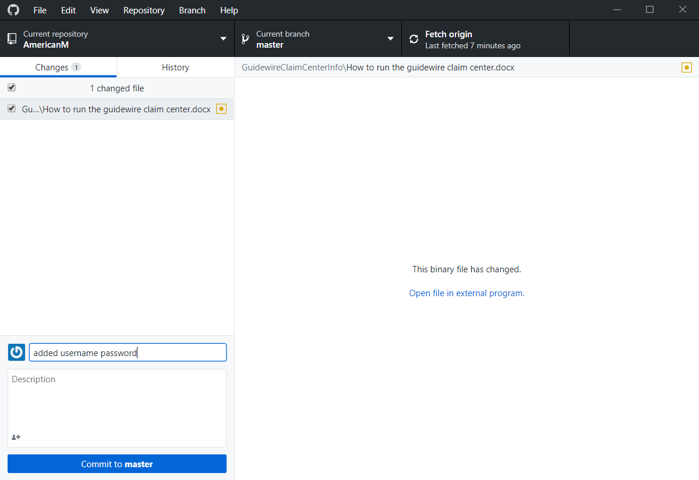

* 1. Enter the comment and click on “Commit to master” button in bottom left corner.
  2. Then click on “Push” in “Repository” menu to push this change to remote repository. After this push everyone can see the changes.

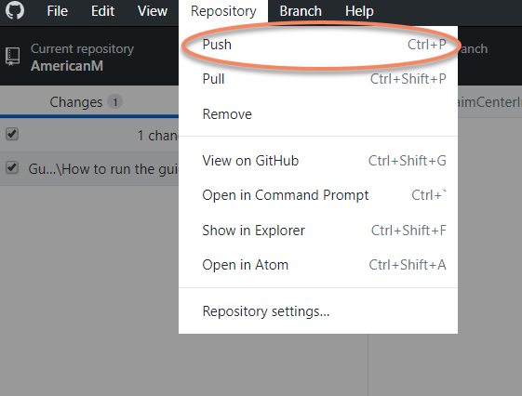

* 1. Use “Pull” in “Repository” menu to pull latest code on your machine which might have changed by anyone who has access to repository.